## Creating a Table That Supports Hive Transactions

create table hive_dml

(emp_id int,

first_name string,

last_name string)

clustered by (emp_id) into 4 buckets

stored as orc

tblproperties ('transactional'='true');

**Inserting Data into a Hive Table**

insert into hive_dml values

(1001501,'alaister','briito'),

(1001502,'anifa','mohammed'),

(1001503,'piyush','manish'),

(1001504,'vijay','karthik'),

(1001505,'narasingh','rao');

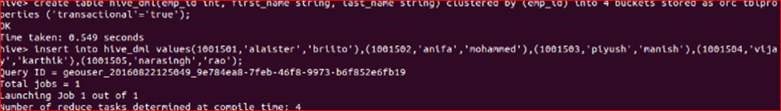

select * from hive_dml;

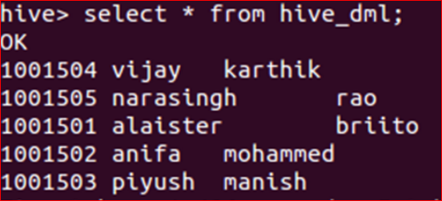

## Updating the Data in Hive Table

update hive_dml set last_name='yadav' where emp_id=1001505;

View the data after complete the update

select * from hive_dml;

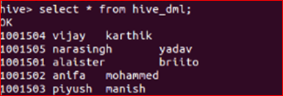

## Deleting a Row from Hive Table

delete from hive_dml where emp_id=1001502;

View the data after complete the delete

select * from hive_dml;

